DAA EXPERIMENT -1

NAME: KODALI SAHITH
ROLL NO: CH.SC.U4CSE24223
SECTION: CSE-C
DATE: 30-11-2025

- Write a program to find the sum of first n natural numbers using user defined function.

CODE:

#include <stdio.h>

int sum(int n) {
return n*(n+1)/2;
}

int main() {
int n, result;

printf("Enter a number: ");
scanf("%d", &n);

result = sum(n);

printf("Sum of first n natural numbers is %d\n", result);

return 0;
}

OUTPUT:

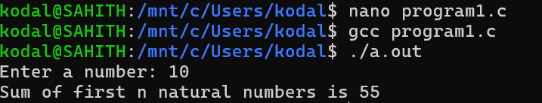

- Write a program to find sum of squares of first n natural numbers using user defined function.
CODE:

#include <stdio.h>

int sum(int n) {
return (n*(n+1)*(2*n+1)/6);
}

int main() {
int n, result;

printf("Enter a number: ");
scanf("%d", &n);

result = sum(n);

printf("Sum of squares of first n natural numbers is %d\n", result);

return 0;
}

OUTPUT:

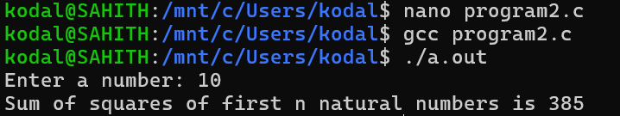

- Write a program to find sum of cubes of first n natural numbers.
CODE:

#include <stdio.h>

int sum(int n) {
return (n*(n+1)/2)^2;
}

int main() {
int n, result;

printf("Enter a number: ");
scanf("%d", &n);

result = sum(n);

printf("Sum of cubes of first n natural numbers is %d\n", result);

return 0;
}

OUTPUT:

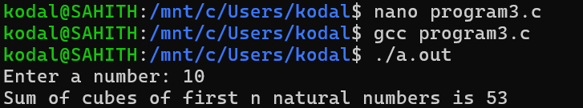

- Write a program to find factorial of a natural number using recursive function.

CODE:

#include <stdio.h>

int factorial(int n) {
if(n == 0 || n == 1)
return 1;
else
return n * factorial(n - 1);
}

int main() {
int n, result;

printf("Enter a number: ");
scanf("%d", &n);

result = factorial(n);

printf("Factorial of %d is %d\n", n, result);

return 0;
}

OUTPUT:

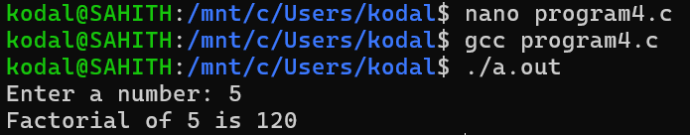

- Write a program to transpose a 3x3 matrix.

CODE:

#include <stdio.h>

int main() {
int a[3][3], transpose[3][3];
int i, j;

printf("Enter elements of 3x3 matrix:\n");

for(i = 0; i < 3; i++) {
for(j = 0; j < 3; j++) {
scanf("%d", &a[i][j]);
}
}

for(i = 0; i < 3; i++) {
for(j = 0; j < 3; j++) {
transpose[j][i] = a[i][j];
}
}

printf("Transpose of the matrix is:\n");

for(i = 0; i < 3; i++) {
for(j = 0; j < 3; j++) {
printf("%d ", transpose[i][j]);
}
printf("\n");
}

return 0;
}

OUTPUT:

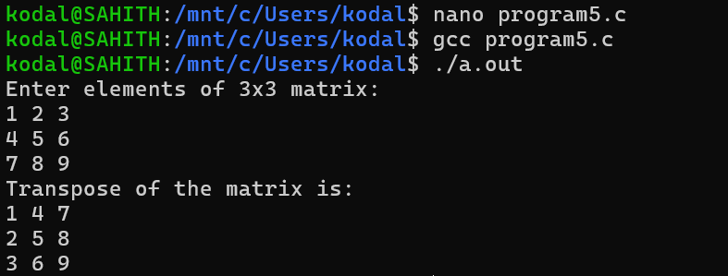

- Write a program to print the Fibonacci series upto a given number using user-defined function(for first n natural numbers).

CODE:

#include <stdio.h>

void fibonacci(int n) {
int a = 0, b = 1, c, i;

printf("Fibonacci Series: ");

for(i = 1; i <= n; i++) {
printf("%d ", a);
c = a + b;
a = b;
b = c;
}
}

int main() {
int n;

printf("Enter the number of terms: ");
scanf("%d", &n);

fibonacci(n);

printf("\n");

return 0;
}

OUTPUT:

